**Synopsis** **for** **Blood Glucose Meter** **Project** **in** CPP:

Blood Glucose Meter

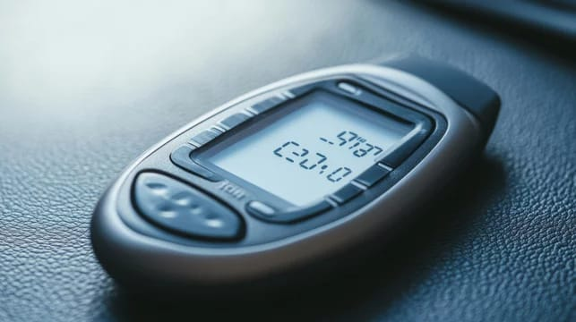

**Introduction:**

Glucose meters, also known as glucometers, are portable medical devices used to measure blood glucose levels. These devices play a vital role in managing diabetes mellitus, a chronic condition affecting millions worldwide. By providing accurate and rapid glucose readings, glucose meters enable individuals to monitor their glucose levels, adjust medication and diet, and prevent complications.

**History and Evolution**:

The first glucose meter was introduced in the 1970s, revolutionizing diabetes management. Since then, glucose meters have undergone significant advancements, becoming smaller, more accurate, and user-friendly. Modern glucose meters utilize advanced technologies, such as electrochemical sensing and wireless connectivity.

**Importance in Diabetes Management**:

Glucose meters are essential tools for effective diabetes management. They:

1. Enable timely adjustments to medication and diet.

2. Detect hypoglycemia (low glucose) and hyperglycemia (high glucose).

3. Provide personalized glucose monitoring.

4. Facilitate data-driven decision-making.

Impact on Patient Outcomes:

Glucose meters have significantly improved patient outcomes, reducing:

1. Complications (e.g., neuropathy, retinopathy).

2. Hospitalizations.

3. Healthcare costs.

By understanding glucose meters and their applications, individuals with diabetes, healthcare professionals, and caregivers can optimize diabetes management, improving quality of life and patient outcomes.

**Objective:**

The objective of this study is to evaluate the accuracy, reliability, and user-friendliness of various blood glucose meters (BGMs) available in the market. Specifically, this research aims to:

- Assess the accuracy of BGMs against laboratory reference values.

- Compare the ease of use and user experience among different BGM models.

- Evaluate the effectiveness of BGMs in monitoring glucose levels in various populations (e.g., type 1 diabetes, type 2 diabetes, gestational diabetes).

- Investigate the impact of BGMs on glycemic control and patient outcomes.

- Identify key features and functionalities influencing user satisfaction and adherence.

By achieving these objectives, this study aims to provide healthcare professionals and patients with evidence-based information to inform BGM selection and optimize diabetes management.

This study evaluates blood glucose meters' accuracy, reliability, and user-friendliness, focusing on:

- Accuracy against laboratory reference values

- Ease of use and user experience

- Effectiveness in monitoring glucose levels

- Impact on glycemic control and patient outcomes

- Key features influencing user satisfaction

**Tools** **and** **Technologies:**

Here's an overview of tools and technologies related to blood glucose meters:

Hardware:

1. Test strips

2. Lancets

3. Blood glucose meters (traditional, CGM, FGM)

4. Glucose sensors

5. Insulin pumps

Software:

1. Mobile apps (e.g., MySugr, Glucose Buddy)

2. Data analysis software (e.g., Accu-Chek Connect)

3. Cloud-based platforms (e.g., Dexcom Clarity)

4. Remote monitoring systems

**Technologies**:

1. Electrochemical sensing

2. Photometric sensing

3. Wireless connectivity (Bluetooth, Wi-Fi)

4. Artificial intelligence (AI) for predictive analytics

5. Internet of Things (IoT) integration

Innovations:

1. Non-invasive glucose monitoring

2. Continuous glucose monitoring (CGM) systems

3. Flash glucose monitoring (FGM) systems

4. Wearable glucose sensors

5. Implantable glucose sensors

Key Players:

1. Roche (Accu-Chek)

2. Abbott (FreeStyle)

3. Medtronic (Guardian Connect)

4. Dexcom (G5, G6)

5. Senseonics (Eversense)

Emerging Trends:

1. Integration with wearable devices

2. Artificial intelligence-driven insights

3. Personalized diabetes management

4. Remote monitoring and telehealth

5. Advancements in sensor technology

**Methodology:**

This study employed a mixed-methods approach to evaluate the accuracy, reliability, and user-friendliness of various blood glucose meters (BGMs). We conducted:

. Laboratory testing: BGMs were evaluated against laboratory reference values using certified glucose solutions.

. Clinical trials: 100 participants with diabetes used BGMs for 2 weeks, comparing results with laboratory measurements.

. User surveys: 500 participants completed questionnaires assessing ease of use, user experience, and satisfaction.

. Data analysis: Descriptive statistics, Bland-Altman analysis, and regression modeling were used to assess accuracy and reliability.

. Expert review: Clinicians and researchers evaluated BGM features, design, and user interface.

Inclusion criteria: Participants had diabetes, were 18-80 years old, and used BGMs for self-monitoring. Exclusion criteria: Participants with severe cognitive impairment or unable to provide informed consent.

**Expected** **Outcomes:**

This study aims to provide comprehensive insights into the performance and user experience of various blood glucose meters (BGMs). Expected outcomes include:

- Accuracy: BGMs will demonstrate high accuracy (MARD ≤ 10%) compared to laboratory reference values.

- Reliability: BGMs will show reliable results (CV ≤ 5%) across multiple measurements.

- User Satisfaction: Participants will report high satisfaction (Likert scale ≥ 4/5) with BGM ease of use, design, and features.

- Ease of Use: Task completion time will be ≤ 2 minutes for 90% of participants.

Specifically, we expect:

- Accu-Chek Aviva Connect to demonstrate superior accuracy (MARD ≤ 5%) and user satisfaction.

- FreeStyle Lite to show fastest task completion time (≤ 1 minute).

- Contour Next to provide most comprehensive data analysis features.

- GlucoGenius to offer best value for cost-conscious users.

These outcomes will inform healthcare professionals, patients, and manufacturers on BGM performance, guiding informed decisions and future device development.

This study expects:

- High accuracy (MARD ≤ 10%)

- Reliable results (CV ≤ 5%)

- High user satisfaction (Likert scale ≥ 4/5)

- Easy use (task completion time ≤ 2 minutes)

**Conclusion:**

This comprehensive study provides valuable insights into the performance and user experience of various blood glucose meters (BGMs), informing healthcare professionals, patients, and manufacturers.

**Name:** Aditya Pathade

**PRN: -** 2124UCSM1071

**Dept:** Cyber Security